
THE ORBIT COLLECTION GOES INTERSTELLAR

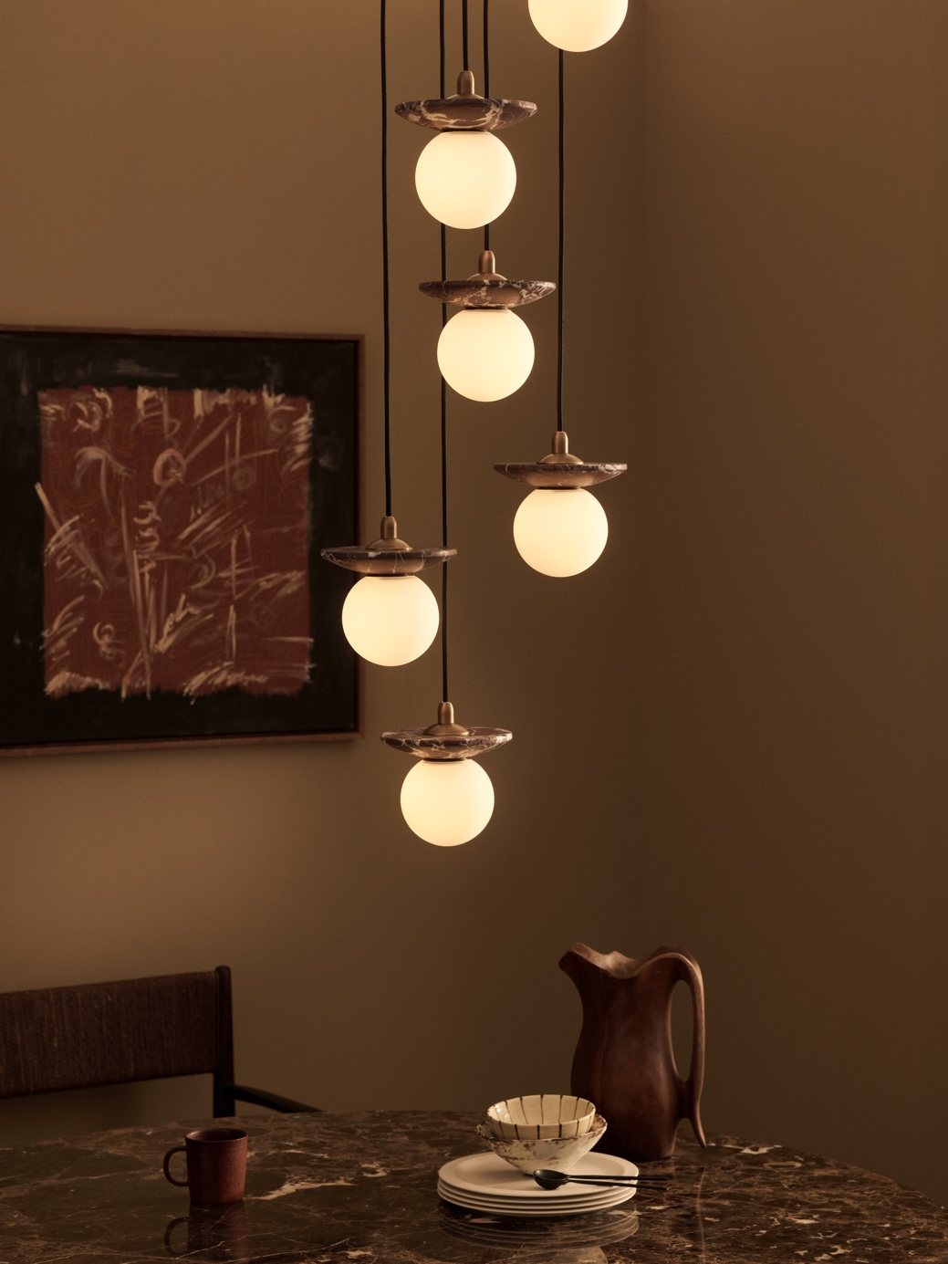

J. Adams & Co expands Orbit Collection with new brass designs and suspension options, launching at Decorex 2024.

J. Adams & Co is thrilled to announce the stellar expansion of their acclaimed Orbit Collection, set to officially launch at Decorex 2024. This exciting update includes new metal finishes and enhanced pendant suspension options, offering unparalleled versatility in lighting solutions.

The new metal surrounds include bronze, antique brass, satin brass and satin nickel. Each of these finishes is meticulously crafted at the brand’s Birmingham metalworks, showcasing a refined stepped design that brings a touch of sophistication and modernity to any setting.

J. Adams & Co is also offering rough sand-cast textures in antique brass and bronze for those seeking a more earthy aesthetic.
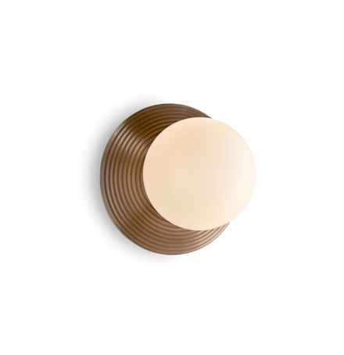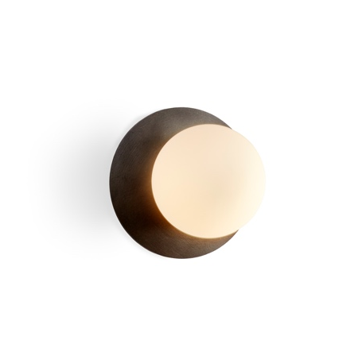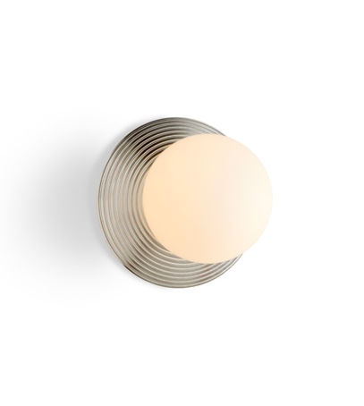
Orbit Wall, ridged antique brass £440 | cast bronze £440 | ridged satin nickel £485

These finishes are produced using a centuries-old process that begins by creating a mould into which molten brass is poured, taking shape as it cools. The cast pieces are then removed, refined and patinated to reveal each piece’s unique textures and a distinct beauty.

In addition to the new metal options, the brand will also be introducing braided cable to the Orbit pendant series. This elegant suspension option is easily adjustable on-site for versatile installation. Standard cables come in black cotton, with a variety of bespoke options available to suit any design preference.

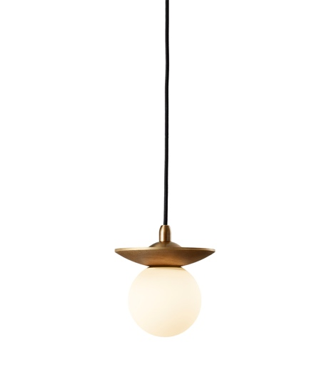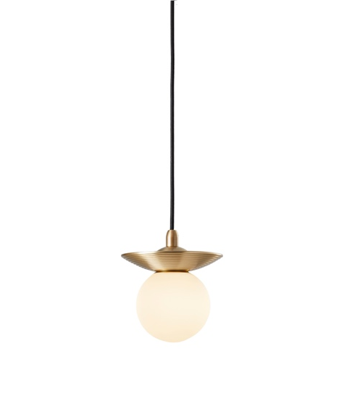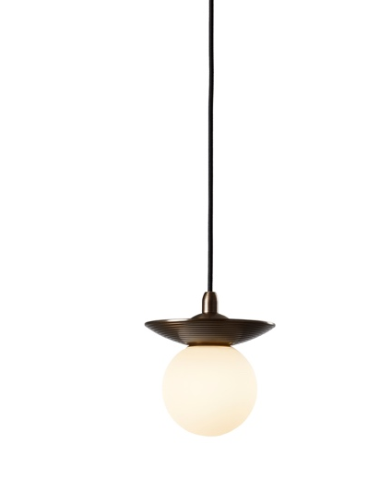

Orbit Pendant, cast antique brass £450 | ridged satin brass £450 | ridged bronze £450

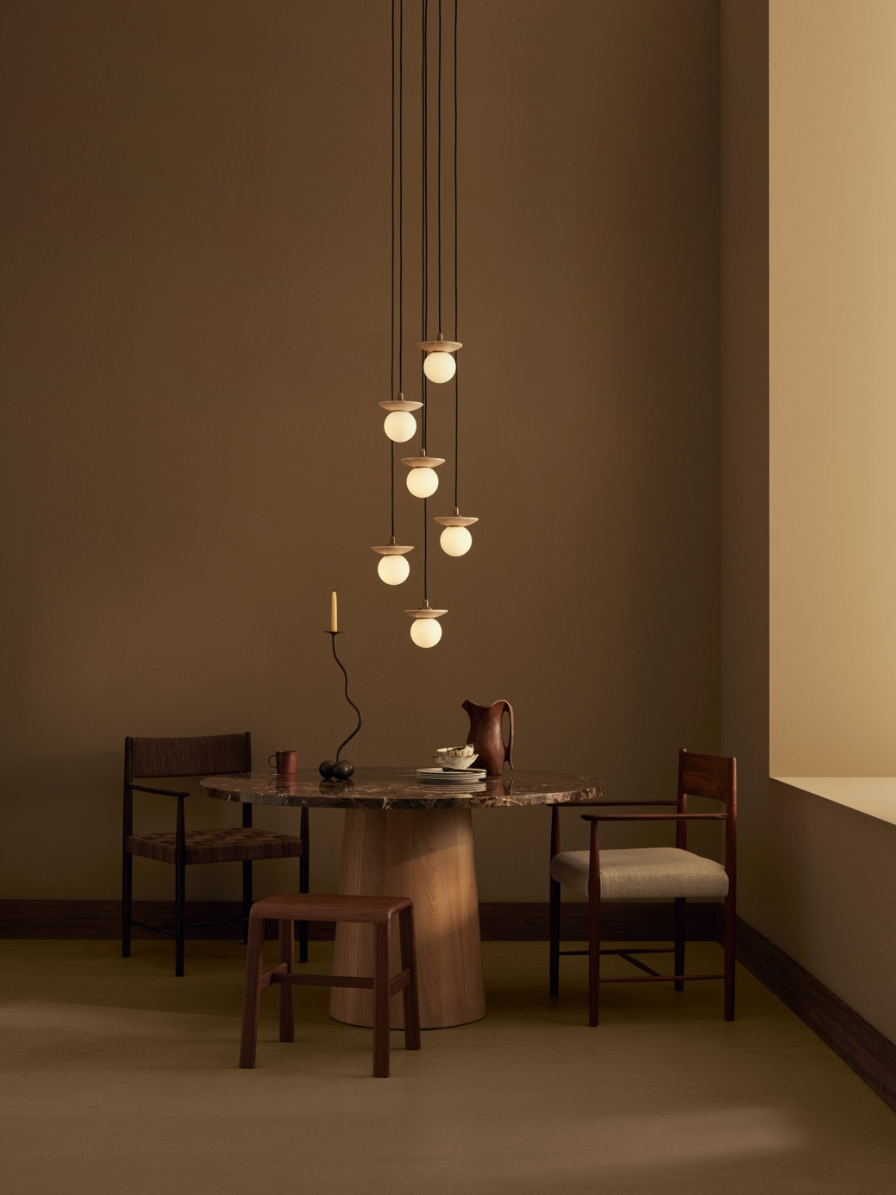

Orbit Pendant, 6 Drop Grouping £2,800

For even greater design flexibility, the Orbit Pendant is now available in 3-drop and 6-drop grouped configurations, and larger groupings on request. These groupings allow for customisable arrangements, making it possible to effortlessly create dramatic, visually captivating lighting installations for any space and style.

For high resolution imagery, videos, quotes and product loans, please contact press@jadamsandco.com

Notes to Editors:
J. Adams & Co is a British lighting manufacturer that specialises in elegant luminaires of unparalleled quality. Handmade in the UK, their Birmingham factory has over half a century of manufacturing and metalworking expertise. The brand seamlessly melds traditional techniques with a nuanced, modern sensibility, focusing on craftsmanship and longevity. The result: refined and contemporary lighting that is built to last.



